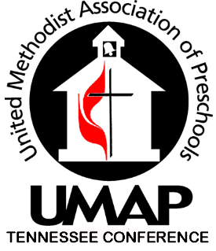

TRAINING INSTITUTE

Meet state training requirements in the comfort of your own school!
The state approved workshops listed here are presented with a Christian aspect and are available to be scheduled in your facility. We will make every effort to tailor our presentations to meet your needs. A minimum payment for 5 participants is required per class. We encourage you to invite other faith-based schools’ staff in your area if you do not have enough for the minimum requirement in your own school.
Fee for 2 hr workshops: UMAP Member - $8.00 per person
Non Member - $12.00 per person
(CPR/First Aid may require a different minimum number of participants and cost is based on contracted instructor’s fee. )
- Refunds will be considered on an individual basis. Substitutes are encouraged.
Registration form and check made payable to UMAP TN will be collected by trainer the day of the workshop.
Ready to schedule a workshop? For further information or to reserve a workshop please contact Gayle Callis @ 615-826-0421 or email to gcallis@me.com

